Carb Confusion: CHO & T2DM
Dr Paul McArdle- Chair of BDA Diabetes Specialist Group

Focus is on the quantity of carbohydrates.
UK: 47% TE, which is less than recommended 50%
China: 67%

SACN (2020)- set CHO recommendations
- NICE: 50% TE
- Diabetes UK: Individualise
Diabetes UK do not actually recommend an amount of CHO since 2003 guidelines. Download doc current guidelines from Diabetes UK.
>American Diabetes Association: Individualise
>DIRECT 59% TE
>LOOK AHEAD 50.8% TE

Current guidelines in the USA reports that evidence suggests no ideal percentage of macronutrients, however, they assert low carbohydrate as an option. Proving the most effective strategy for improving glycaemic control.
How do we define low carb?
There is no internationally accepted levels of low CHO. They have been suggested by Feinman et al.
When we are talking about low carb, are we talking low or very low?
- 46% of energy is considered a high CHO diet (>225g)

SACN(2020): Lower carbohydrate diets for adults with T2DM
8 systematic reviews in search- focus on 4 higher quality reviews.
Lower carb studies- avg. 40% TE (range 14%-50%)
Higher carb studies- avg. 55% TE (range 23%-65%)

Primary outcomes- bodyweight, HBA1C
Short term (3-12 months): HBA1C was shown to demonstrate a greater reduction in the lower carb group.
Longer term: Body weight shown no difference. Long term, up to 24 months, the results for HBA1C was inconsistent and past 24 months there is adequate evidence to show there is no difference.
This therefore shows an improvement of blood glucose control up to 12 months with a lower carb diet.

Systematic Review/Meta-analysis: CHO restriction for glycaemic control
-Very low carb
-Low carb (50-130g)
-Moderate plus
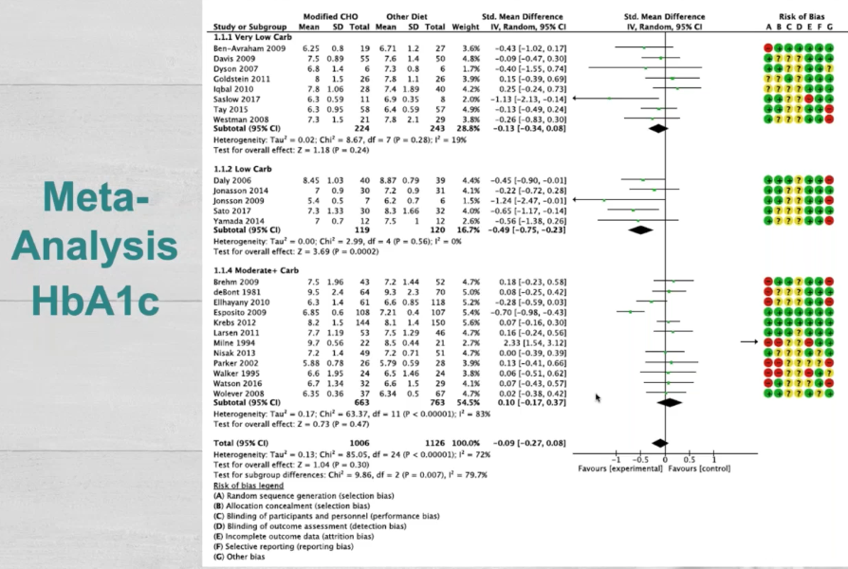

Line down the middle demonstrates no effect. Low carbohydrate demonstrated an improvement more than that of a very low carbohydrate diet for short term- supporting SACN.

Diabetes UK currently do not recommend low carb diets for T1DM- there is not enough research.

Glycaemic Index & Glycaemic Load

Anomalies- jam, chocolate vs watermelon, white bread. If you calculate GL you will have an insight in to why GL is more useful
GL = Amount of CHO (g) x GI
100
Glycaemic Load is more useful predictor of glycaemic response.

Many other dietary approaches
- Mediterranean
- Nordic
- Low Fat
- DASH
- Low CHO
- Low GI/GL

Educating patients on which sort of foods and the quantities and timing will impact your glycaemic response is important.

Huntriss, Boocock & McArdle – Dietary CHO restriction as a management strategy for adults with T2DM: Exploring the opinions of dietitians
For and against CHO restriction
In favour | Against
- Felt Eatwell guide not appropriate to 73% of dietitians  - 85% described low carb as ‘achievable’ | - Nutrition: fibre, fat, deficiencies: CHO is present in veg, fruit, wholegrains!  - Risk of hypoglycaemia  - Practicalities; cost and meal planning

Patient views
Useful to see the same dietitian
Cultural competence is required
Dietitian did not ask them about favourite foods which is a big influencer of what an individual eats
Assessing knowledge and beliefs is really important

Increasing awareness
>Identify CHO-containing foods
>Quantities

Resources for patients
- Meal plans at Diabetes UK: low carb meal planner for example
- Carbs and cals, world foods, gestational diabetes
- Low carb program app: NHS (slightly controversial advice)
- Diabetes UK learning zone

Resources for healthcare professionals
- CDEP: Cambridge Diabetes Education Programme.
Organised into modules and recognised as CPD- certificate. Some employers will pay for you.

Summary
- Low CHO diets may be effective short term for T2DM- emphasis on complex CHO.
- Finding out knowledge gaps is important.
- Individualised dietary advice is important whilst integrating key themes- culture, preferences: GET TO KNOW THEM!
- Clear explanations are required to patients.
- Signpost to resources

